CLASSROOM ATTENDANCE USING FACE RECOGNITION
21CSE454T/ COMPUTER VISION
CASE STUDY PROJECT REPORT
Submitted by
DEEPAK R (RA2311003020005)
Under the guidance of
Dr. Adlene Ebenezer P
(Assistant Professor, Department of Computer Science and Engineering)
VII SEMESTER / IV YEAR
COMPUTER SCIENCE AND ENGINEERING FACULTY OF ENGINEERING AND TECHNOLOGY



SRM INSTITUTE OF SCIENCE AND TECHNOLOGY RAMAPURAM, CHENNAI
JUNE 2026
ABSTRACT

Attendance management plays a vital role in educational institutions by monitoring student participation and maintaining academic records. Traditional attendance systems are generally manual, time-consuming, and prone to errors such as proxy attendance and inaccurate record keeping. To address these challenges, this project presents a Classroom Attendance System using Face Recognition that automates the attendance process while improving accuracy, efficiency, and security.
The proposed system uses a webcam to capture facial images of students and identify them in real time. Face detection is performed using the Haar Cascade Classifier, and recognition is achieved through the Local Binary Pattern Histogram (LBPH) algorithm. The LBPH algorithm is selected because it provides reliable recognition performance and works effectively under different lighting conditions.
To enhance security, a random challenge-based liveness detection mechanism is incorporated into the system .The user is instructed to perform a random challenge, such as turning the head left or right., before attendance is recorded. Facial landmarks are tracked using MediaPipe Face Mesh to verify that the challenge is completed by a live person. This approach helps prevent spoofing attacks using photographs or prerecorded videos.
The system also supports check-in and check-out operations, voice-based notifications, real-time attendance monitoring, and automatic storage of attendance records in Microsoft Excel format. Attendance details such as name, date, check-in time, check-out time, duration, and status are maintained automatically. Experimental results demonstrate that the system accurately recognizes authorized users, verifies liveness, and records attendance efficiently. The proposed solution reduces manual effort, minimizes attendance fraud, and provides a secure and user-friendly approach for classroom attendance management.

TABLE OF CONTENTS

S.NO | TITLE | PAGE NO
1. | Introduction | 1
2. | System Architecture | 4
3. | Methodology | 5
 | 3.1 Implementation | 5
 | 3.2 Data Set | 10
 | 3.3 Algorithm | 10
 | 3.4 Experimental Setup | 12
4. | Results | 14
5. | Conclusion | 18

CHAPTER 1
INTRODUCTION

  - BACKGROUND
Attendance management is an important activity in educational institutions as it helps monitor student participation, academic performance, and discipline. Traditionally, attendance is recorded manually by teachers using attendance registers or paper-based methods. Although widely used, manual attendance systems consume valuable class time and are prone to errors such as incorrect entries, duplicate records, and proxy attendance. Managing and maintaining large attendance records also becomes difficult and time-consuming for faculty members.
With the rapid advancement of computer vision and artificial intelligence technologies, automated attendance systems have gained significant attention. Face recognition is one of the most effective biometric techniques used for personal identification because facial features are unique to each individual. Unlike fingerprint or card-based systems, face recognition provides a contactless and user-friendly method for authentication. This makes it highly suitable for educational environments where attendance needs to be recorded quickly and efficiently.
The integration of computer vision techniques with attendance management systems can significantly improve the reliability and efficiency of attendance recording. Automated face recognition systems reduce human intervention, eliminate manual errors, and provide real-time attendance monitoring. As a result, educational institutions can save time and maintain accurate attendance records.

  - PROBLEM STATEMENT
Manual attendance systems face several limitations. The process of calling student names and marking attendance consumes classroom time that could otherwise be used for academic activities. Human errors may occur during attendance recording, leading to inaccurate records. In addition, proxy attendance remains a major concern, as students may mark attendance on behalf of absent classmates.
Existing face recognition attendance systems also face security challenges. Some systems can be deceived using photographs or prerecorded videos of registered individuals. Such spoofing attacks reduce the reliability of biometric attendance systems and create opportunities for fraudulent attendance marking.
Therefore, there is a need for a secure and automated attendance system that not only recognizes students accurately but also verifies the presence of a live person before attendance is recorded.
  - OBJECTIVE OF THE PROJECT
The primary objective of this project is to develop a Classroom Attendance System using Face Recognition that automates the attendance process while ensuring security and reliability.
The specific objectives of the project are:
• To detect and recognize student faces using computer vision techniques.
• To automate attendance recording and reduce manual effort.
• To prevent proxy attendance through biometric verification.
• To implement liveness detection using a random challenge mechanism.
• To provide voice-based instructions and notifications.
• To generate attendance records automatically in Microsoft Excel format.
• To support both check-in and check-out attendance operations.
• To improve attendance accuracy and efficiency in classroom environments.

  - SCOPE OF THE PROJECT
The proposed system is designed primarily for educational institutions such as schools, colleges, universities, and training centers. The system can be deployed in classrooms, laboratories, examination halls, and other academic environments where attendance tracking is required.
The scope of the project includes face detection, face recognition, liveness verification, attendance recording, and report generation. The system uses a webcam to capture facial images and verify student identity in real time. Attendance information is stored digitally and can be accessed for future reference.
Although the current implementation is designed for a limited number of registered users, the system can be expanded to support larger datasets and multiple classrooms. Future enhancements may include cloud-based storage, mobile integration, and deep learning-based recognition techniques.

  - OVERVIEW OF THE PROPOSED SYSTEM
The proposed attendance system combines face recognition and challenge-based liveness detection to create a secure attendance management solution. The system first captures the user's face using a webcam and detects facial features through OpenCV. A random challenge, such as turning the head left or right, is generated to verify liveness. MediaPipe Face Mesh is used to track facial landmarks and ensure that the user performs the required action.
After successful liveness verification, the Local Binary Pattern Histogram (LBPH) algorithm is used to recognize the student's face. Once the identity is confirmed, attendance is automatically recorded in an Excel file. The system also provides voice feedback to guide users through the attendance process. Check-in and check-out details are stored along with timestamps, enabling accurate attendance tracking and duration calculation.
The proposed system offers several advantages over traditional attendance methods. It improves security, eliminates manual attendance recording, reduces administrative workload, and provides an efficient and user-friendly attendance management solution.

CHAPTER 2
SYSTEM ARCHITECTURE DIAGRAM

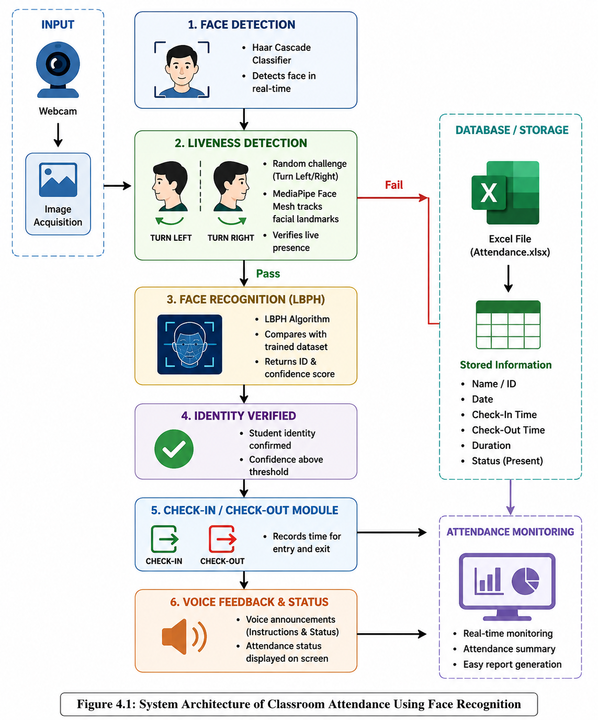
Figure 2.1 System Architecture of Classroom Attendance System using Face Recognition

CHAPTER 3
METHODOLOGY

  - IMPLEMENTATION
The Classroom Attendance System was implemented using Python and various computer vision libraries. The project is organized into multiple modules to improve maintainability and functionality. The folder structure of the project is shown below.
Project Structure
- attendance_system.py – Main application file responsible for face recognition, liveness verification, check-in/check-out operations, voice notifications, and attendance recording.
- collect_faces.py – Used to collect facial images of users through a webcam and store them in the dataset folder for training.
- train_model.py – Processes the collected facial images and trains the LBPH face recognition model.
- dataset/ – Contains facial images of registered users captured during dataset creation.
- trainer/ – Stores the trained face recognition model (trainer.yml) and label information (labels.pkl).
- attendance.xlsx – Excel file used to store attendance records, including check-in time, check-out time, duration, and attendance status.
- challenge_test.py – Used to test and validate the challenge-based liveness detection mechanism

collect_faces.py
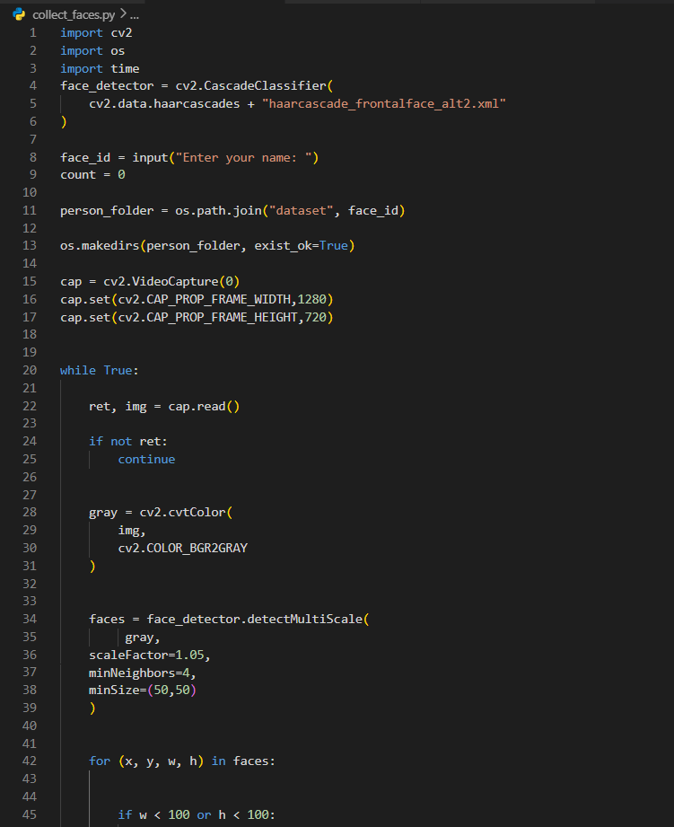
train_model.py
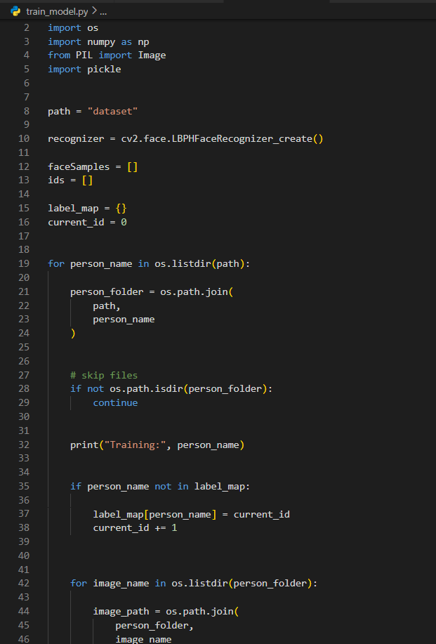
trainer.yml
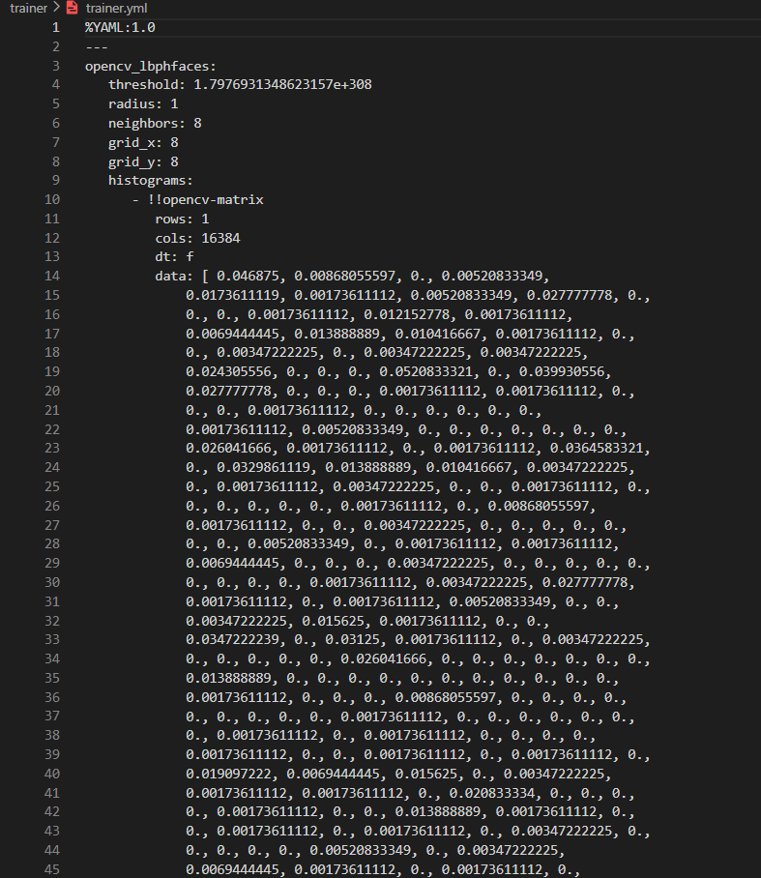

attendance_system.py
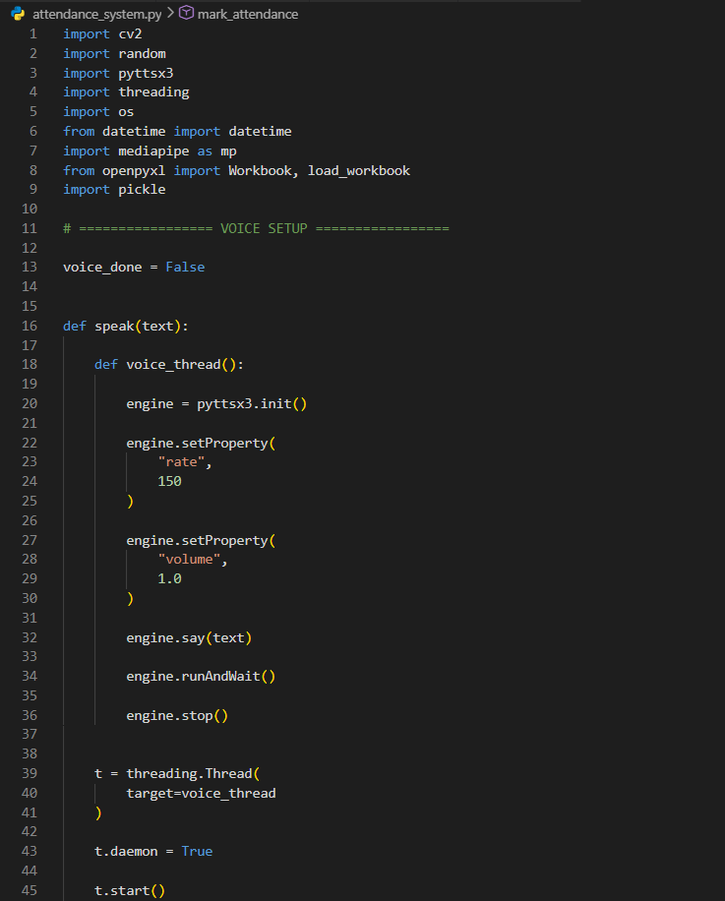
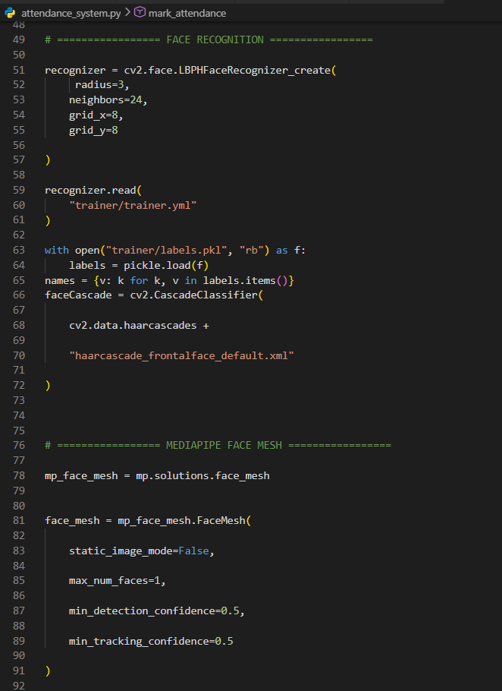
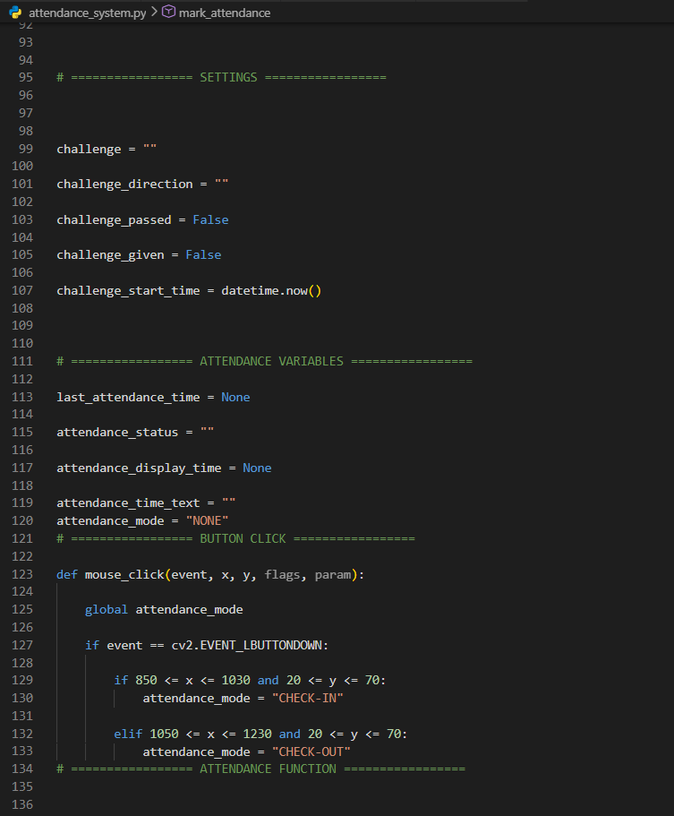
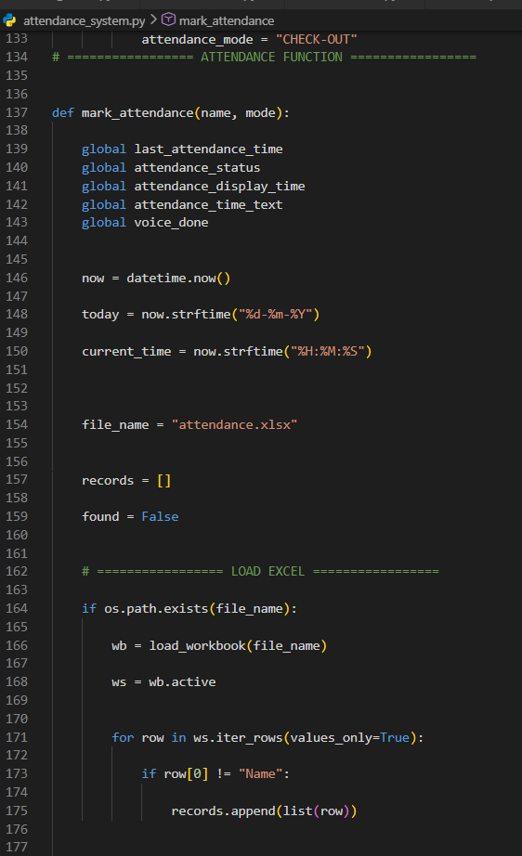
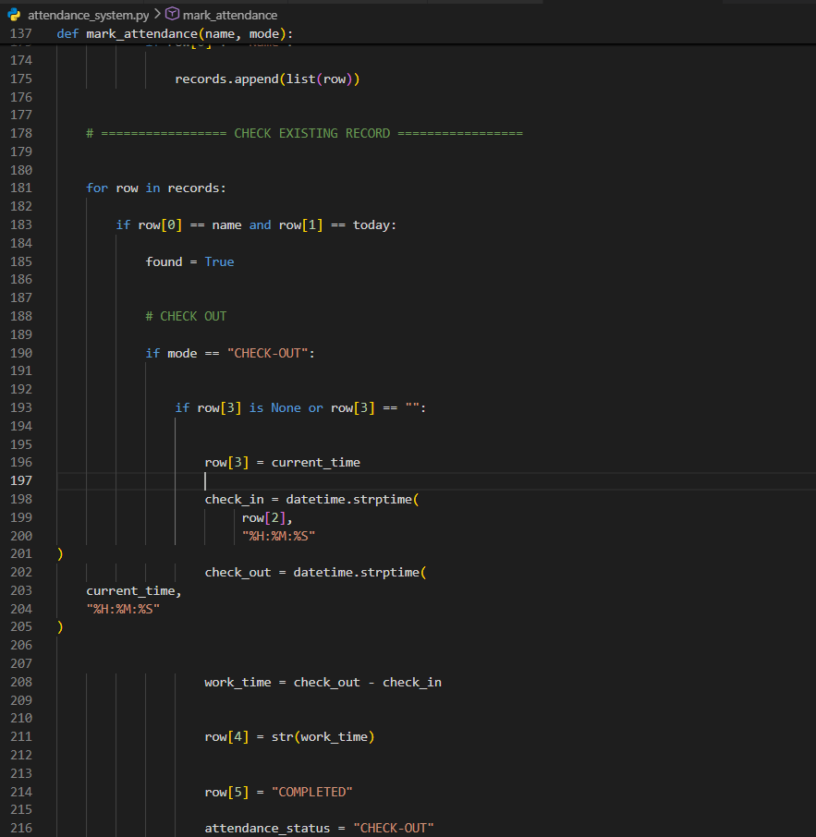

attendance.xlsx

  - DATASET
The dataset used in this project consists of facial images collected using a webcam
Table 3.2.1 Dataset Details
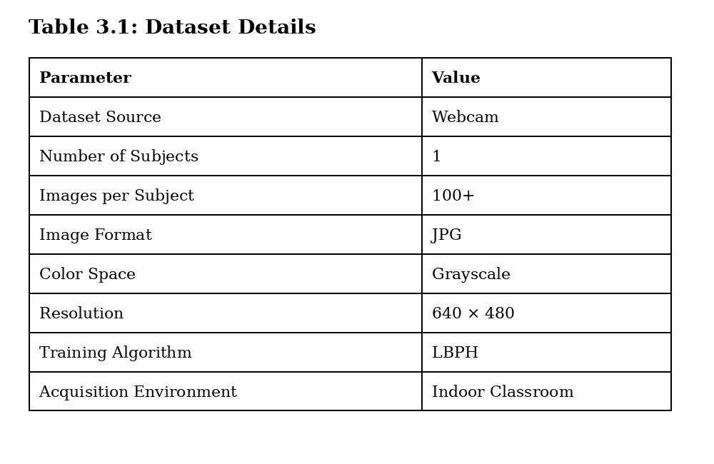
Images were collected under:
- Different lighting conditions
- Different facial angles
- Slight expression variations
The collected images were used to train the LBPH face recognizer.

  - ALGORITHM
    - Haar Cascade Algorithm
Steps:
- Capture image.
- Convert to grayscale.
- Apply Haar features.
- Detect face location.
- Extract face region.
The detected face is passed to the recognition stage.

3.3.2 LBPH Algorithm
The Local Binary Pattern Histogram algorithm is used for face recognition.
Working Steps:
- Divide image into cells.
- Compare neighboring pixels.
- Generate binary patterns.
- Convert binary values into decimal values.
- Create histograms.
- Compare histograms with trained dataset.
The face with the minimum distance is selected as the recognized user.

3.3.3 Liveness Detection Algorithm
Steps:
- Generate random challenge.
- Detect facial landmarks.
- Monitor nose movement.
- Verify challenge completion.
- Approve or reject attendance.
This process ensures that the system interacts with a live user.

    - Attendance Recording Algorithm
Steps:
- Verify user identity.
- Check attendance database.
- Record check-in or check-out time.
- Update attendance status.
- Save information to Excel file.
- Display confirmation message.
  - EXPERIMENTAL SETUP

Hardware Requirements
Table 3.4.1 Hardware Requirements
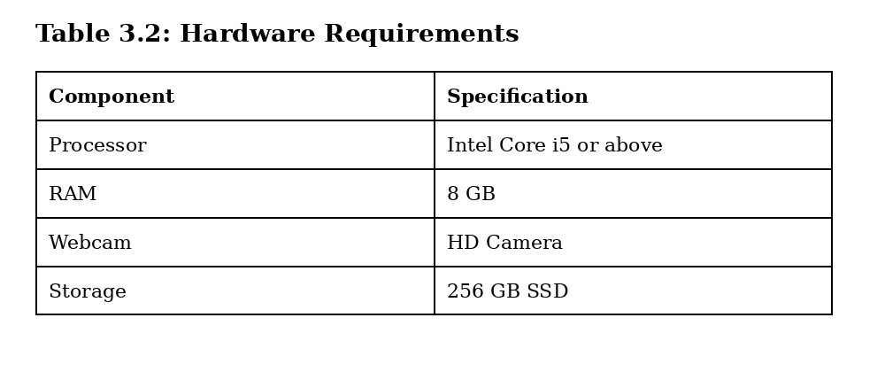

Software Requirements
Table 3.4.2 Software Requirements
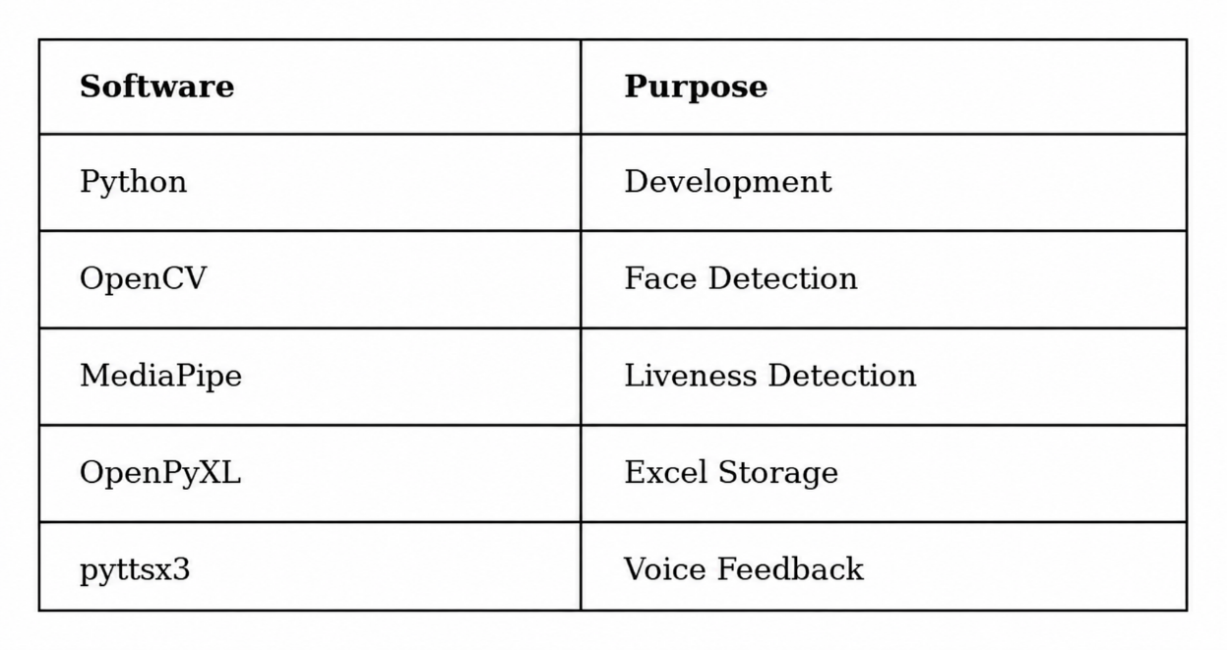

Working Model Explanation
Step 1: Face Capture
The system activates the webcam and continuously captures video frames from the user.
Step 2: Face Detection
The captured frame is converted into grayscale format, and the Haar Cascade Classifier is applied to detect the presence and location of a human face
Step 3: Random Challenge Generation
To prevent spoofing attacks, the system generates a random challenge instruction such as "Turn Left" or "Turn Right." The challenge is displayed on the screen and announced through voice feedback.
Step 4: Liveness Verification
MediaPipe Face Mesh detects facial landmarks and tracks the movement of the user's face..
Step 5: Face Recognition
After successful liveness verification, the extracted face image is passed to the LBPH face recognition model.
Step 6: Attendance Selection
The recognized user selects either the Check-In or Check-Out option. The system verifies the user's attendance status to avoid duplicate entries.
Step 7: Attendance Recording
The attendance details, including user name, date, and current timestamp, are automatically stored in the Excel attendance database. The system updates the attendance record accordingly.
Step 8: Voice Notification
A voice message is generated using the pyttsx3 text-to-speech engine. The user receives audio confirmation such as "Attendance Marked Successfully," "Already Marked," or "Already Checked Out."
Step 9: Status Display
Finally, the attendance status is displayed on the screen. The system shows the user's name, attendance result, check-in/check-out information, and any relevant notifications, providing immediate feedback to the user.

CHAPTER 4
RESULTS AND OUTPUT

  - Results
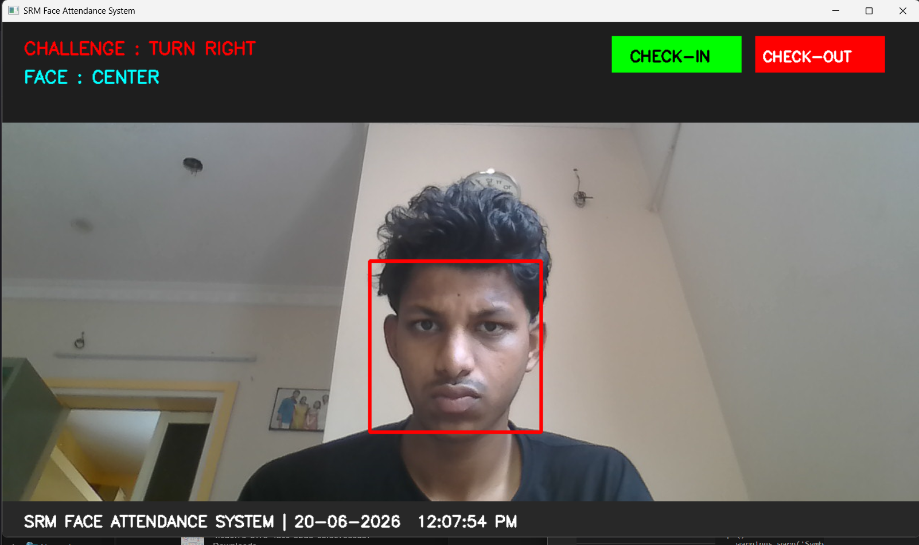
Figure 4.1.1 Initial System Interface with Random Challenge Generation

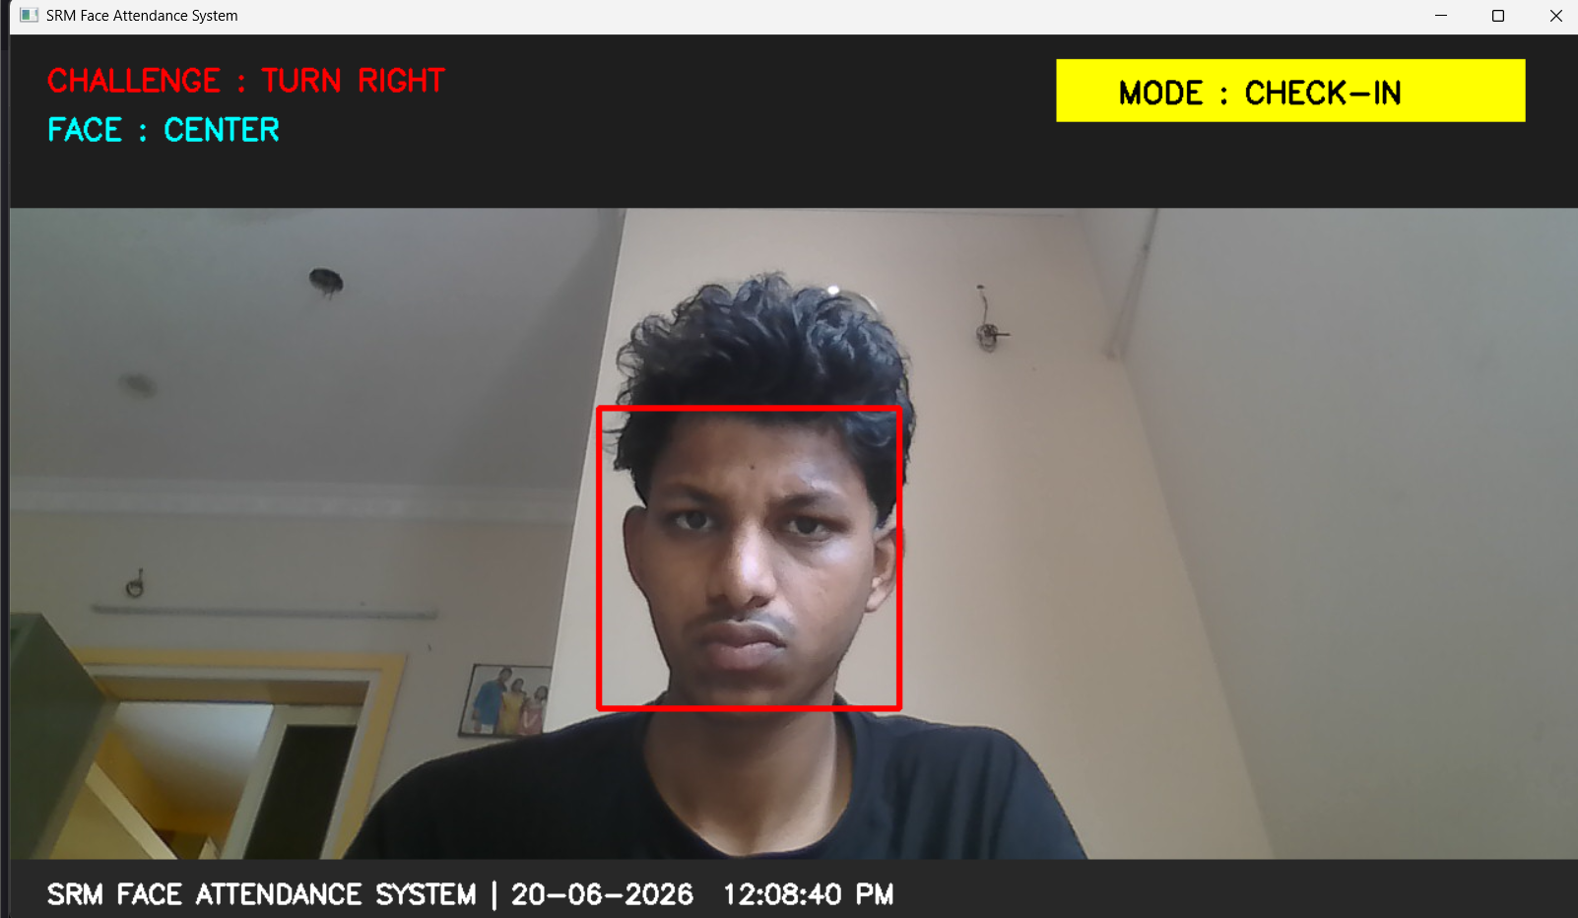
Figure 4.1.2 Classroom Attendance System in Check-In Mode

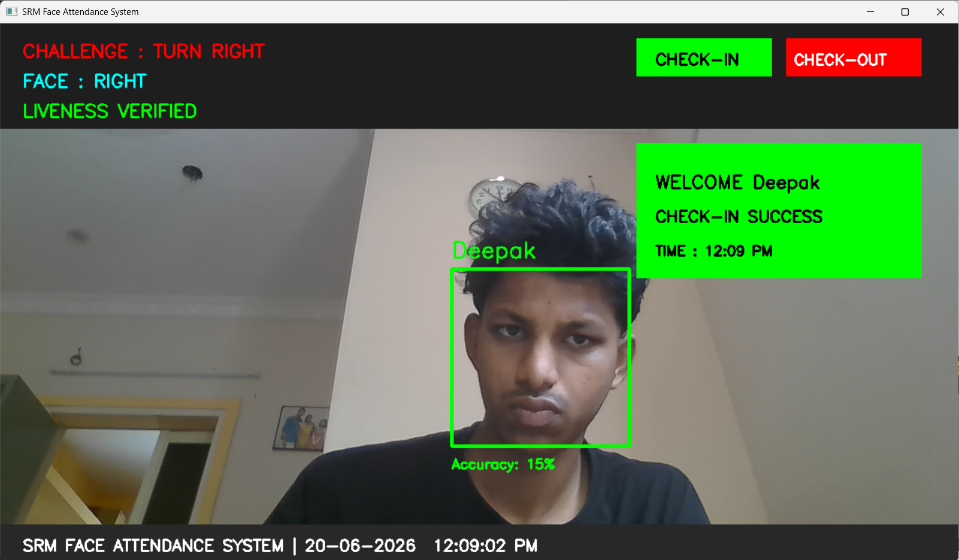
Figure 4.1.3 Successful Attendance Check-In Confirmation after Face Recognition and Liveness Verificat
Figure 4.1.4 Attendance Database Updated with Check-In Details

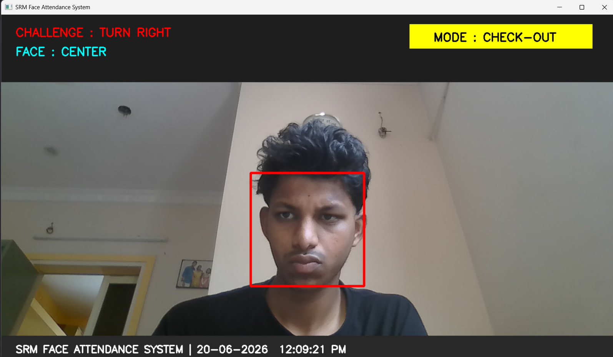
Figure 4.1.5 Classroom Attendance System in Check-Out

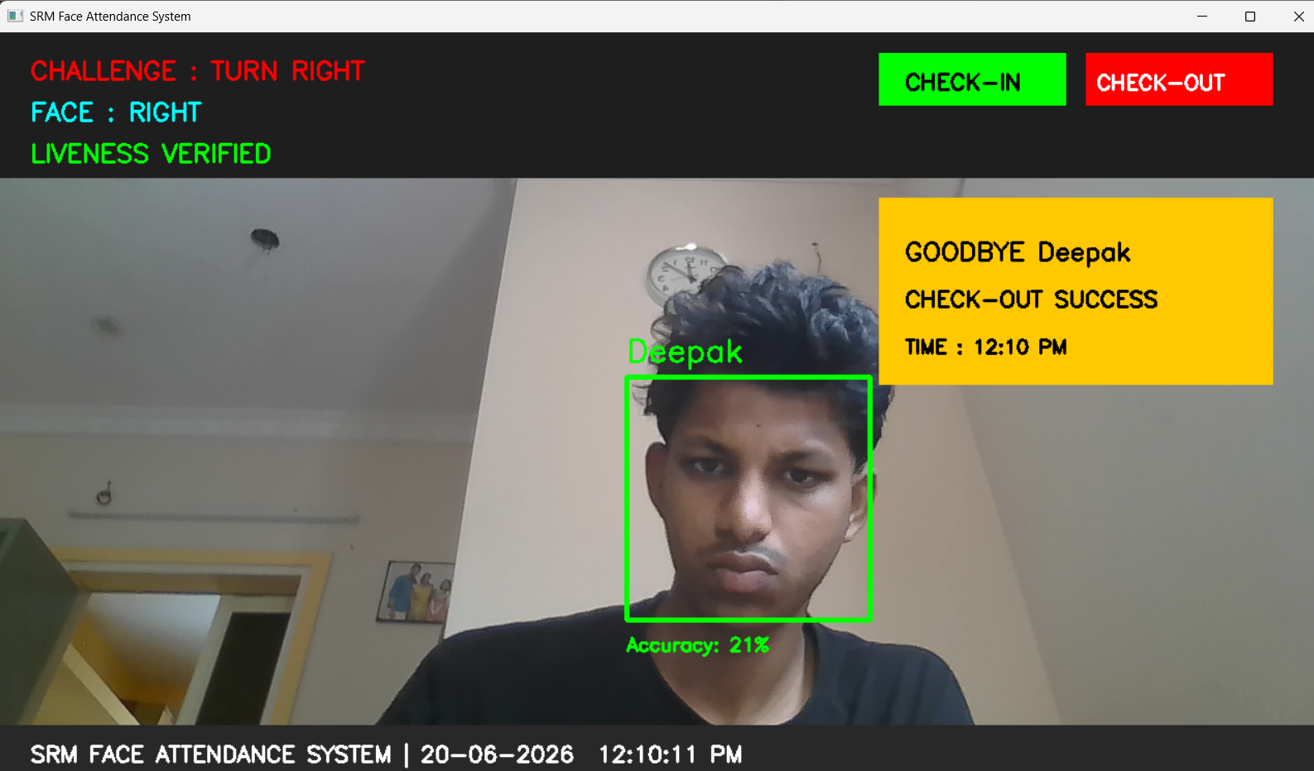
Figure 4.1.6 Successful Attendance Check-Out Confirmation after Face Recognition and Liveness Verification

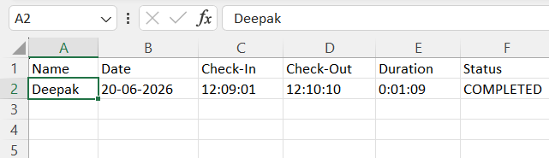
Figure 4.1.7 Attendance Database Updated after Check-Out Details
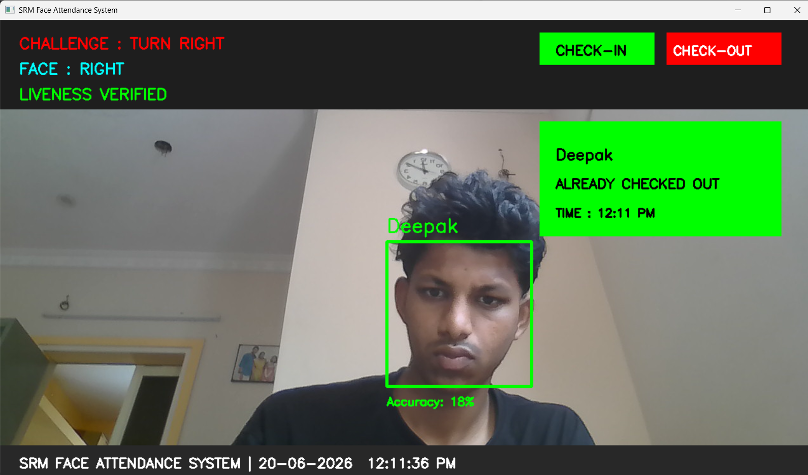
Figure 4.1.8 System Notification for Already Checked-Out User

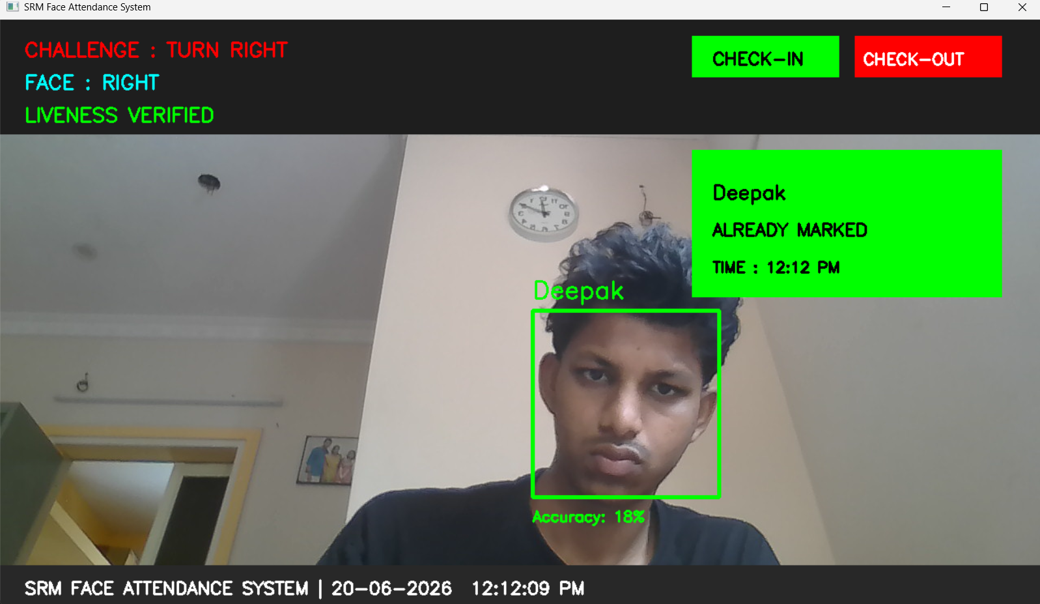
Figure 4.1.9 System Notification for Already Marked Attendance

The experimental results demonstrate that the system can efficiently automate classroom attendance while minimizing manual intervention. The integration of liveness detection significantly improves system security and reduces the possibility of proxy attendance.

Comparison of output with Existing model

Attendance management is an essential task in educational institutions. Traditional attendance systems, such as manual attendance registers, RFID cards, and basic biometric systems, have several limitations including time consumption, proxy attendance, and manual record maintenance. Basic face recognition systems also face security issues as they can be fooled using photographs or recorded videos.
The proposed Classroom Attendance System using Face Recognition overcomes these limitations by integrating face recognition, liveness detection, voice feedback, and automatic attendance recording. Before marking attendance, the system performs a random challenge-based liveness test by asking users to turn their head left or right.
During testing, the system accurately detected faces, verified liveness, recognized registered users, and automatically recorded attendance.
Compared to conventional attendance systems, the proposed solution offers improved security, higher accuracy, and fully automated attendance management. Attendance records are stored in Excel format and include details such as student name, date, check-in time, check-out time, duration, and attendance status. These features make the system more reliable, efficient, and suitable for modern classroom environments.

Table 4.1.1. Comparison with Existing Attendance Systems
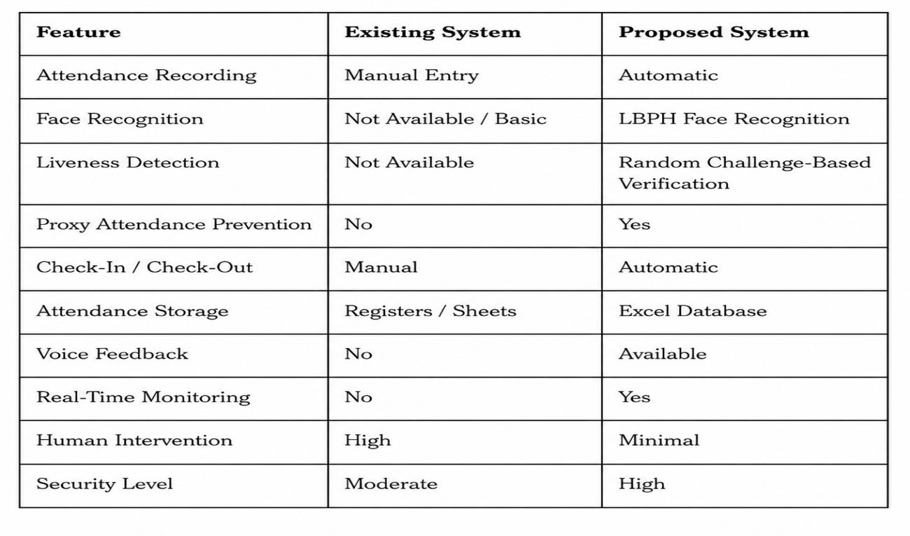

CHAPTER 5
CONCLUSION

The Classroom Attendance System using Face Recognition was successfully designed and implemented using computer vision techniques. The system automates the attendance process by detecting and recognizing registered students through facial recognition, thereby eliminating the need for traditional manual attendance methods. The integration of the LBPH face recognition algorithm enabled reliable identification of users in real-time, while the Haar Cascade Classifier efficiently detected faces from webcam video streams.

To enhance security, a challenge-based liveness detection mechanism was incorporated using MediaPipe Face Mesh. The system randomly instructs users to turn their head left or right before attendance is recorded. This feature effectively prevents spoofing attacks using photographs or videos and ensures that attendance is marked only for a live person.

The developed system also provides check-in and check-out functionality, voice-based feedback, real-time attendance monitoring, and automatic storage of attendance records in Microsoft Excel format. Experimental results demonstrated that the system accurately recognized authorized users, successfully verified liveness, and maintained attendance records without manual intervention.

Overall, the proposed system offers a secure, efficient, and user-friendly solution for classroom attendance management. It reduces administrative workload, improves attendance accuracy, and minimizes the possibility of proxy attendance. Future enhancements may include multi-user recognition, cloud-based attendance storage, mobile application integration, and deep learning-based facial recognition models for improved performance and scalability.

REFERENCES

[1] Gonzalez, R. C., and Woods, R. E., Digital Image Processing, 4th Edition, Pearson Education, 2018.
[2] Szeliski, R., Computer Vision: Algorithms and Applications, 2nd Edition, Springer, 2022.
[3] Ahonen, T., Hadid, A., and Pietikäinen, M., "Face Recognition with Local Binary Patterns," European Conference on Computer Vision (ECCV), pp. 469–481, 2004.
[4] Viola, P., and Jones, M., "Rapid Object Detection using a Boosted Cascade of Simple Features," IEEE Conference on Computer Vision and Pattern Recognition (CVPR), 2001.
[5] Turk, M., and Pentland, A., "Eigenfaces for Recognition," Journal of Cognitive Neuroscience, Vol. 3, No. 1, pp. 71–86, 1991.
[6] Zhao, W., Chellappa, R., Phillips, P. J., and Rosenfeld, A., "Face Recognition: A Literature Survey," ACM Computing Surveys, Vol. 35, No. 4, pp. 399–458, 2003.
[7] Bradski, G., "The OpenCV Library," Dr. Dobb's Journal of Software Tools, 2000.
[8] OpenCV Documentation. Available: https://opencv.org
[9] MediaPipe Documentation. Available: https://developers.google.com/mediapipe
[10] Python Software Foundation, Python Documentation. Available: https://www.python.org
[11] OpenPyXL Documentation. Available: https://openpyxl.readthedocs.io
[12] pyttsx3 Documentation. Available: https://pyttsx3.readthedocs.io
[13] Dalal, N., and Triggs, B., "Histograms of Oriented Gradients for Human Detection," IEEE Conference on Computer Vision and Pattern Recognition (CVPR), 2005.
[14] Deng, J., Guo, J., Xue, N., and Zafeiriou, S., "ArcFace: Additive Angular Margin Loss for Deep Face Recognition," IEEE Conference on Computer Vision and Pattern Recognition (CVPR), 2019.
[15] Taigman, Y., Yang, M., Ranzato, M., and Wolf, L., "DeepFace: Closing the Gap to Human-Level Performance in Face Verification," IEEE Conference on Computer Vision and Pattern Recognition (CVPR), 2014.

